23rd May 2019

**“AVID GT” Coming Factory-Equipped on Toyota’s RAV4 Crossover SUV**

YOKOHAMA has begun supplying its “AVID GT” passenger car tyre as original equipment (OE) for Toyota Motor Corporation’s new RAV4 crossover SUV, which was first launched in North America in 2018 and has since been introduced in Japan*, South Korea, Europe and other markets. The new RAV4 is coming equipped with 235/55R19 101V size tyres.  
*Japan launch was in April 2019  
  
The AVID GT was developed by applying the basic design and material technologies featured in YOKOHAMA’s “environmentally, human, and socially friendly” BluEarth global tyre brand to the AVID passenger car tyre previously sold in the North American market. Developed to deliver a safe ride during a sudden snowfall, the “AVID GT” bears the “M+S” (mud + snow) marking on its sidewall. In addition, the tyre enhances the vehicle’s fuel efficiency while also providing superior drivability and safety.

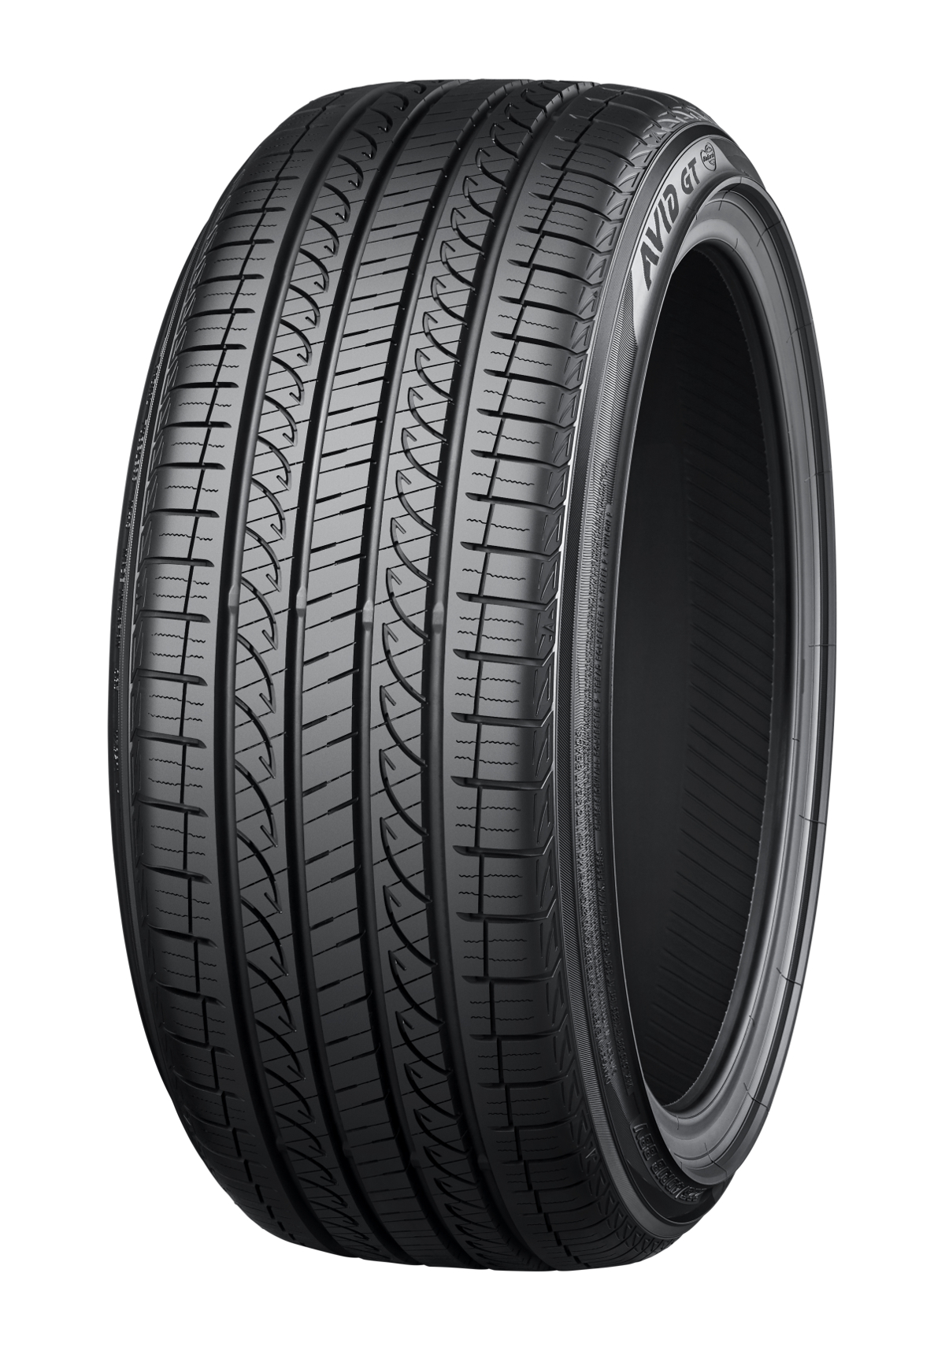

*YOKOHAMA “AVID GT”*



*“Toyota’s new RAV4” *This photo is used with the permission of Toyota Motor Corporation. Reprint or other usage of this image without prior permission from Toyota Motor is strictly prohibited.*